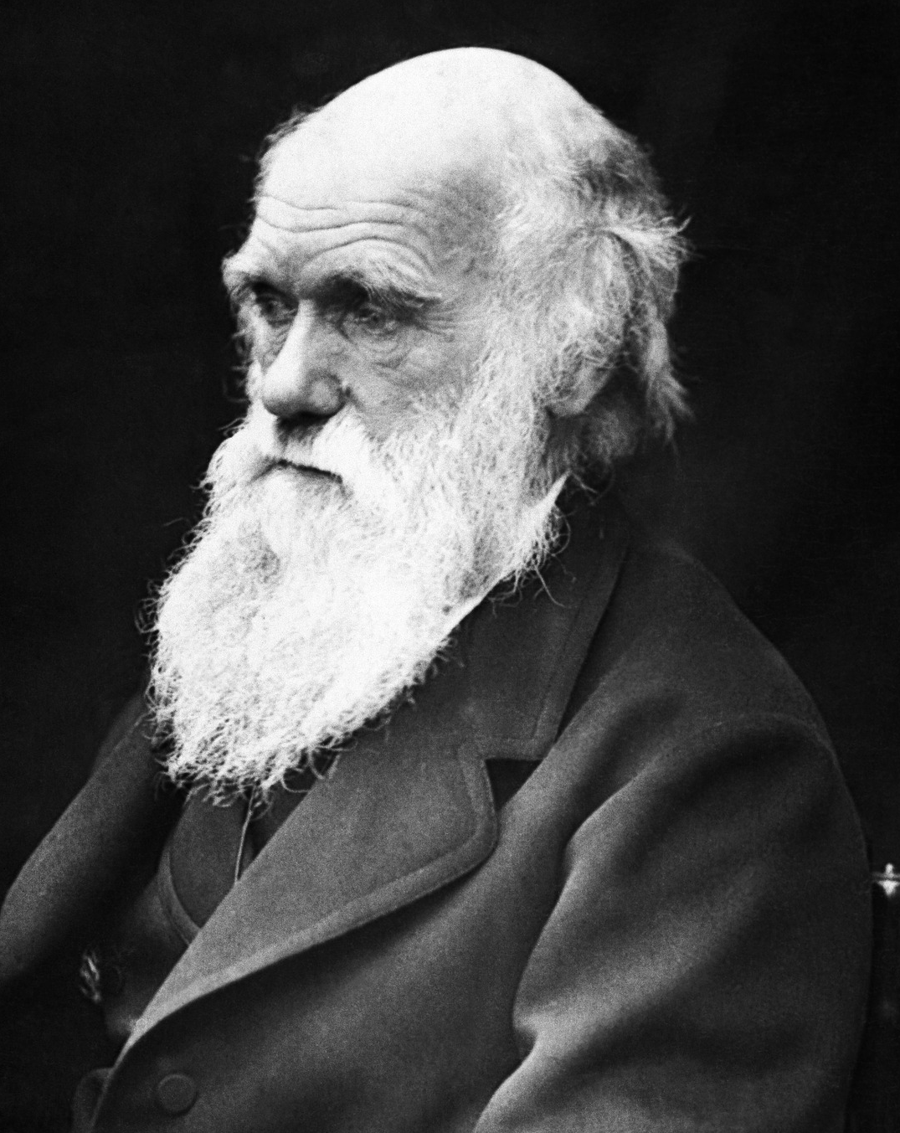
Match the animal to the adaptations
When Charles Darwin was studying the wildlife on the Galapagos Islands, he was amazed by the variety of life that he saw. He noticed that different plants and animals seem to have adapted special features to survive in their environment.
Match the picture cards to the information and label cards to find out how different plants and animals have adapted to the environment they live in.

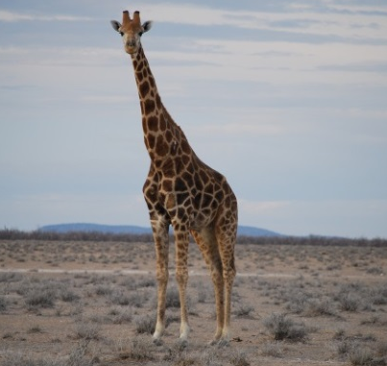 | They can be found in very cold climates such as Alaska. They grow close to the ground to keep out of the harsh conditions and they are covered in fine, silky hairs to keep warm. | Pufferfish
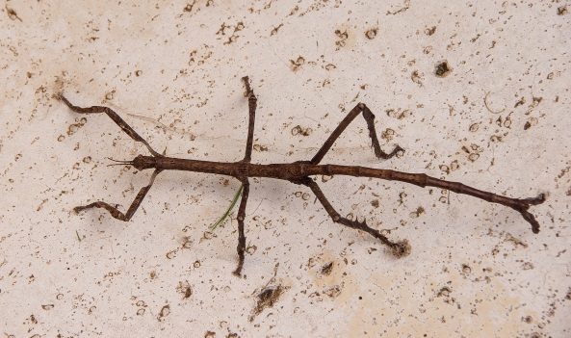 | They have wide, flat leaves to help them float at the surface of the water. They have thorns on the bottom of the leaves which help to support them and stop them being eaten by predators. | Prairie grass
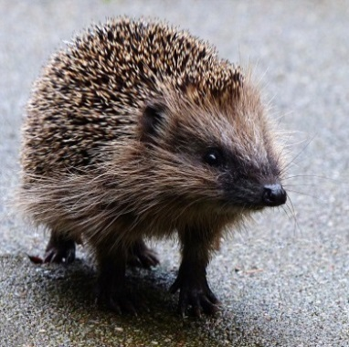 | These plants cannot get the nutrients they need from the soil in their habitats so they have adapted to digest small animals and insects. They have trigger ‘hairs’ inside their trap pads which cause the trap to snap shut when they sense movement. This stops their prey from escaping. | Cacti

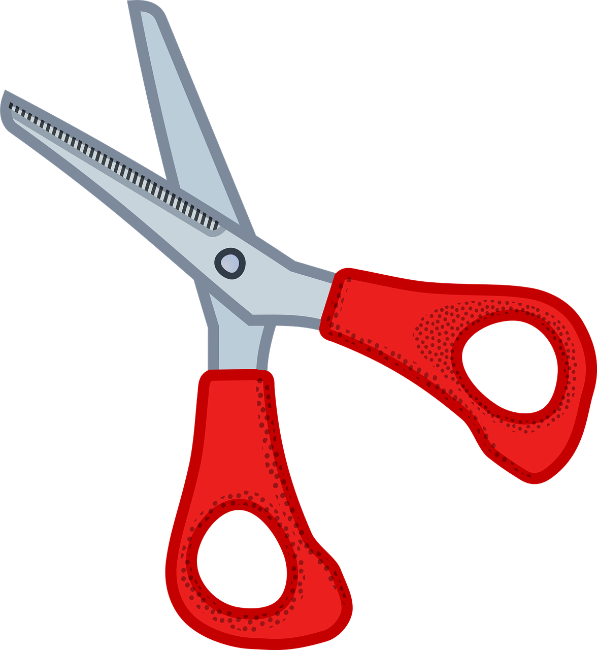

 | It can be found in dry and hot climates where droughts and fires are common. Their roots grow deep into the soil to reach as much water as possible. The roots are also able to survive fires so even when the parts above the ground are destroyed, they can regrow quickly. | Rose
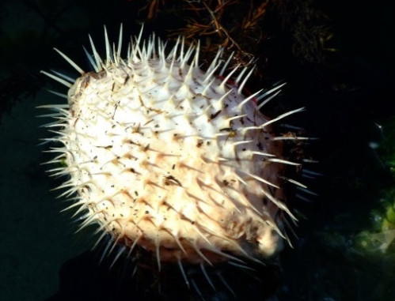 | They have thorns along their stems. These thorns protect them from being eaten by predators. They also help the plant to hold on to other plants when growing over them. | Giraffe
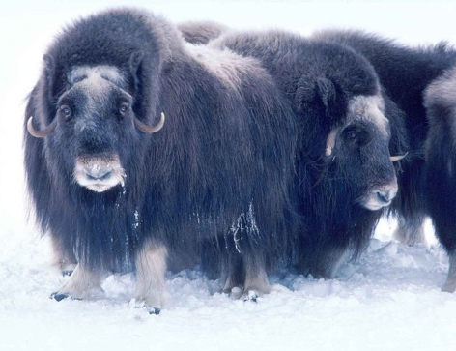 | They can be found in rainforests. They have big, fan-shaped leaves which help them to catch sunlight and water. Their leaves are split into segments so when it rains heavily, they can drain the extra water. | Venus flytrap
 | These creatures look exactly as their name suggests. This helps them to blend into their environment to hide from predators who mistake them for twigs and branches. | Water lily

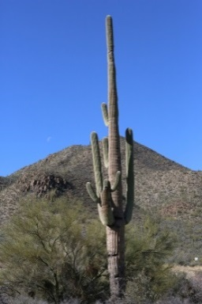 | When they are under threat, they pump air or water into their stretchy stomachs which makes them double in size! They can hardly move in this state but all of their spikes stick out around them to stop predators eating them. When the threat has left, they return to their smaller size. | Hedgehog
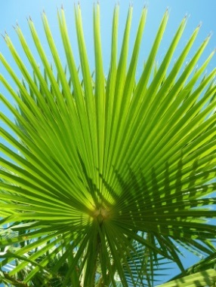 | This animal has long, thick, shaggy hair which almost touches the ground. This hair helps them to survive the freezing cold Alaskan temperatures. They shed some of this hair for the summer to stop them overheating. | Pasque flower
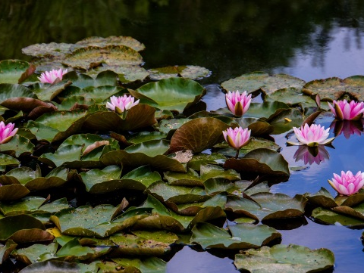 | This creature has white fur during the Winter and reddish-brown fur during the Summer. The change to their colour helps them to stay camouflaged from predators throughout the year. | Arctic fox
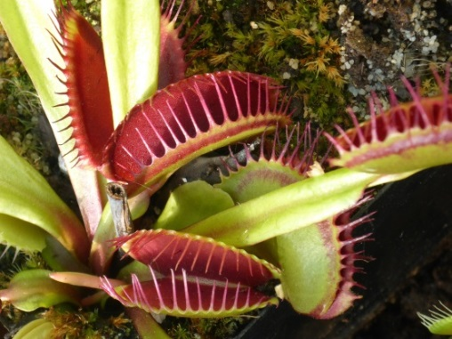 | They hibernate in the Winter when it is cold and there is less food. By sleeping through the winter months, they save a lot of energy which helps them to survive. They also have spikes on their bodies to protect themselves from predators. | Musk ox

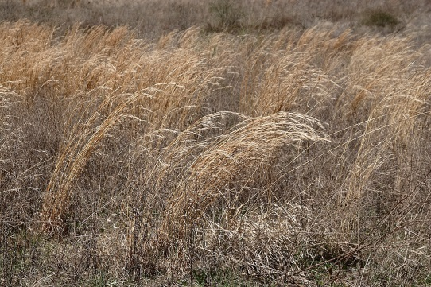 | Many live in the desert where there is often a shortage of food and water. They store fat in humps on their back so when they cannot find food, their body can use this for energy. | Stick insect
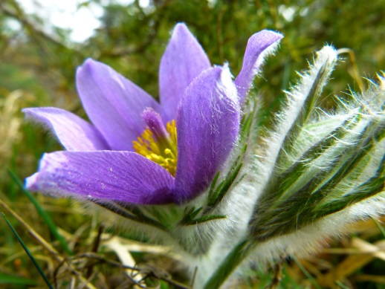 | These animals have long necks and tongues helping them to reach up high for food. They are also believed to have long necks to help them fight for their mates. | Fan palm
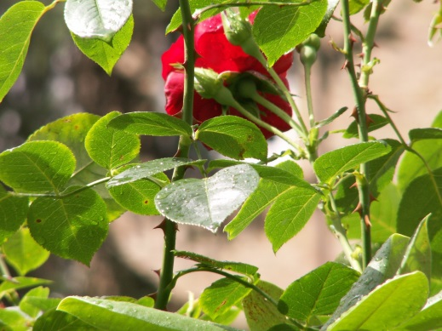 | They can be found in the desert where there is very little water. They have spines instead of leaves to reduce the amount of water they lose. The spines also protect them from being eaten by animals. They store water in their stems to help them to survive the driest spells. | Camel

©Rklawton, 25 April 2006, commons.wikimedia.org/wiki/File:Prairie_grass.JPG, (CC BY-SA 2.5)

