Match the feature to the description
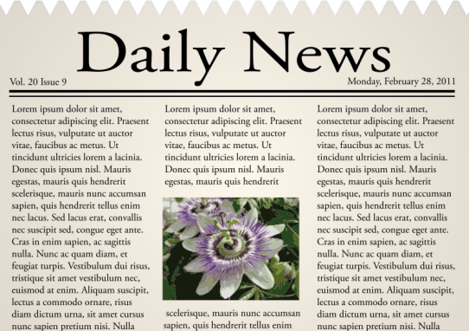
Cut out each of the feature and description cards below, shuffle them and then ask children in pairs, or groups, to match the feature to the description. Once matched, these cards can be used for display.
A further challenge for children could be to identify each feature from a newspaper page and label it accordingly to produce a quick guide for display.

Headline
Opening sentence
Byline
Past tense
Quote
Main paragraphs
Picture
Caption
Full sentences and correct punctuation
Facts

Usually only four or five words. It tries to attract the interest of the reader by telling them what the story is about, in a short and interesting way.
To tell the reader who has written the article.
Sometimes articles will include what an eye-witness said or an expert’s opinion. These will be in speech marks.
Provides more detail about the event, in particular it answers the questions how and why. It is written in columns.

A sentence explaining the photograph.

This helps to grab the reader’s attention.
This is the particular way in which text is written in a news article. Newspapers inform the reader about events which have already happened.
It will set the scene and summarise the main points of the article: who, what, when and where.
These are things that have really happened or are true. Newspapers should be based on them.
Helps the reader to understand the text.

