 | More than one way to halve a …  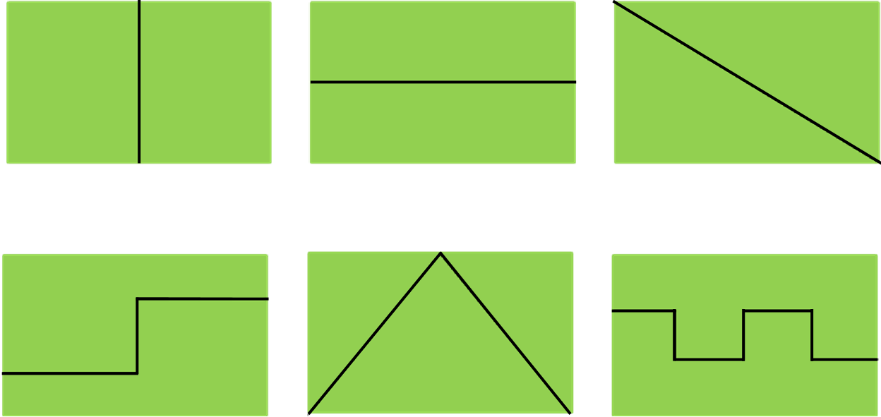  Explore ways of finding half of a piece of paper by challenging children to fold it in different ways. Then move on to using centimetre squared paper to look at dividing the paper in different ways with an equal number of squares in each half. It can help with understanding if you display a whole next to its half for comparison. Interesting designs and a variety of coloured paper makes for a colourful display.
 | Fraction tiles  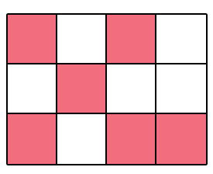  Create arrays using large carpet tiles which total eight, twelve and sixteen. Ask the children to explore ways of turning over the tiles to show ¹/₂, ¹/₄ or, where possible, ¹/₃. Children can then use pieces of squared paper to colour patterns that show the same fractions. Display different patterns showing the same fraction so that the children can see there are many different ways of representing the same fraction.
 | Pizza factory  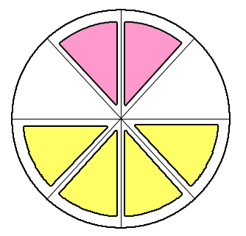  Use a selection of cardboard circles divided into halves, thirds, quarters and eighths. Using scraps of coloured paper to represent pizza toppings – yellow for cheese, pink for ham etc. – set up your pizza factory giving children instructions for the fraction of the pizza to be covered with each topping.  Ham and cheese: ¹/₂ cheese and ¹/₄ ham  Extend to using the pizza toppings to explore fractions of amounts rather than shapes by setting a total number of topping pieces allowed and giving the children a ‘recipe’ to follow. For example: if there are a total of twenty pieces of topping ask the children to make ¹/₂ olive, ¹/₄ ham and ¹/₄ mushroom.
 | Washing line fractions  Make sure your children are used to counting in fractions – halves, quarters and thirds – by challenging the children to count forwards and backwards from different starting numbers. Prepare laminated cardboard washing items: t-shirts, socks, dresses etc. and, using a dry-wipe pen, write on to each item a mixed number e.g. 3¹/₄, 5 ¹/₂ etc. Armed with a washing line (marked with the start and end numbers) and pegs, challenge children to peg their washing in the correct position. Include some equivalent fractions e.g. ²/₄ and ¹/₂ or ³/₃ and 1.

 | Cuisenaire fractions  Using sets of Cuisenaire rods, begin by challenging the children to take a rod and then to find two rods that are half. For example a yellow rod is half of an orange rod and purple rods are half of brown ones! Extend this further by asking children to find a rod that can be made up of three smaller rods (a blue rod can be made up of three light green ones). Remember to emphasise that the rods used to make up the larger rod must be the same colour. Introduce the numerical value of the rods to show the link between fractions, quantities and shapes  Rods can be placed together to create a fraction wall where children can begin to explore equivalence.  

