 | Step in, step out. Select a commonly contracted phrase such as ‘do not’ and write out each separate letter onto individual whiteboards. You will also require an additional whiteboard showing an apostrophe. Each ‘letter’ whiteboard is then held up by a child to display the phrase to the rest of the class. The class must then decide which child/children need to step out and where the ‘apostrophe’ whiteboard needs to step in to contract the phrase. This activity is easily adapted to look at expanding contractions.
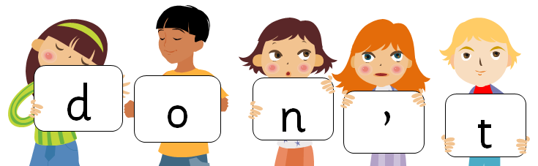

 | Flip flap. Contractions are normally associated with informal language use such as when reporting direct speech or writing notes. Take an example of very formal language and ask the children to flip the speech into an informal tone by highlighting all the phrases that could be replaced with contractions. Try using broadsheet newspaper articles or speeches by important people such as the prime minister and the queen or make up your own as sources of formal language.
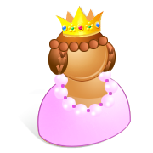
Philip, it is almost time to feed the corgis, do you not agree? I cannot bear to see them so hungry.
 | Happy families. Explore looking at possessive apostrophes by examining family relationships. Children begin by recording their relationship to their parent, for example ‘I am my mother’s daughter’. They carry on building up sets of relationships to describe the family links: ‘My mother is my grandmother’s daughter’ or ‘My father is my uncle’s brother’. This can then be expanded to describe relationships between more than one family member such as ‘I am my brothers’ sister’ where there is more than one brother!
 | Whose toys? Using different themes such as toys, pets, hobbies ask children to construct lists for those which are boys’, girls’ or children’s as a way of exploring possessive apostrophes for plurals. For example: cars, bikes and Lego are boys’ toys. Dolls, skipping ropes and prams are girls’ toys. Teddies, paints and hula hoops are children’s toys. It’s also a great way of challenging gender stereotypes by looking at the groups that children construct.
 | Eat you’re green’s. A great way to create some real grammar geeks is by getting them out and about looking for apostrophe errors. Ask children to be on the lookout for errors in books, newspapers and signs, snapping any errors on mobile phones. Use the images to create a fun display.

