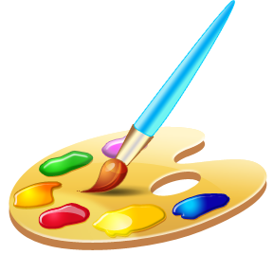
Monet was an impressionist painter. He wasn’t interested in painting pictures that were accurate in the way that a photograph is. He developed his artistic style to give an impression or an idea of his subject. The results are often much more interesting and engaging than an actual photograph might ever have been.

You will need:  - A sheet of coloured paper – greens, browns and yellows work best.  - Oil or chalk pastels.  - Poster paint.  - Brushes. | 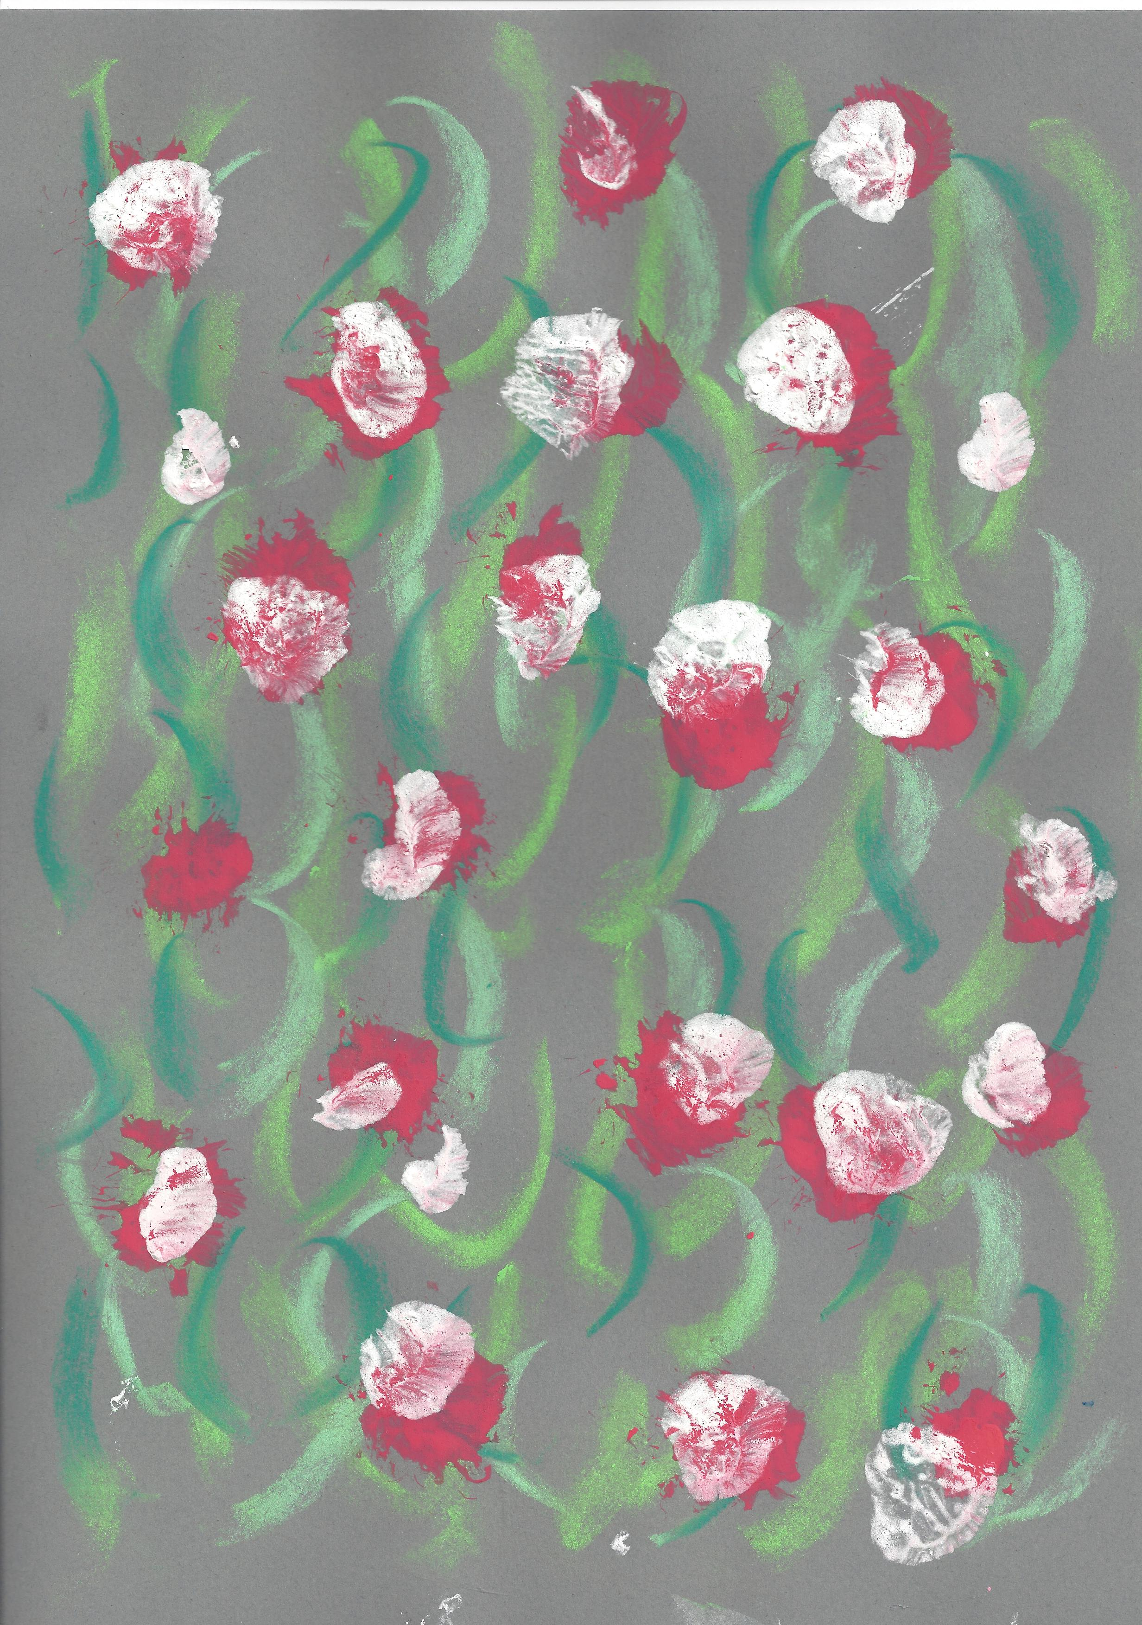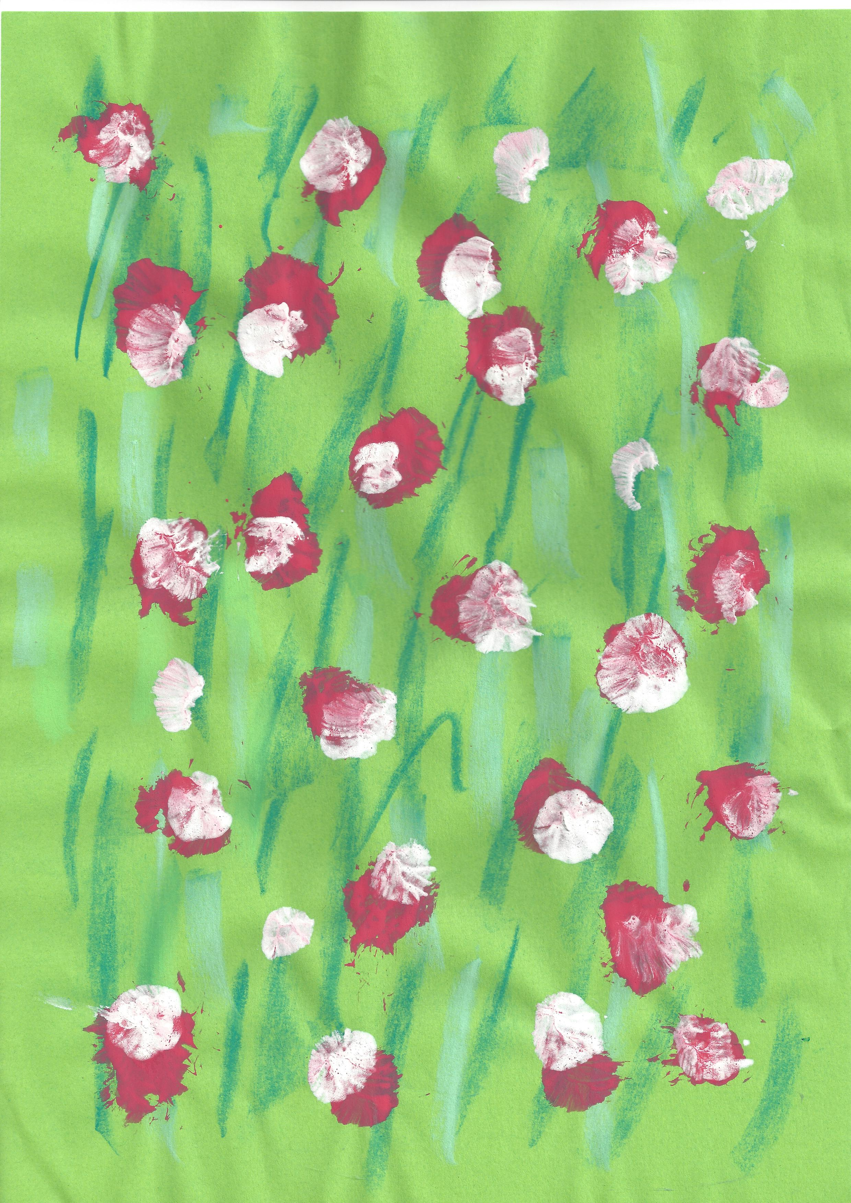 | Instructions:  - Using the pastels and a sheet of coloured paper, draw loose lines to create the effect of foliage (plants).  - Use bright coloured poster paint and a large brush held upright to ‘dab blobs’ over the pastel marks.  - While the paint is still wet, use a clean brush to dab blobs of white on top of the coloured paint.

