How to create a life cycle wheel:

- Print the life cycle cards onto card and cut out.
- Cut and stick the images in order on to the back of the ‘life cycle’ wheel.
- Colour the front cover.
- Attach the front cover to the life cycle sequence with a brass paper fastener.


Life cycle of a penguin

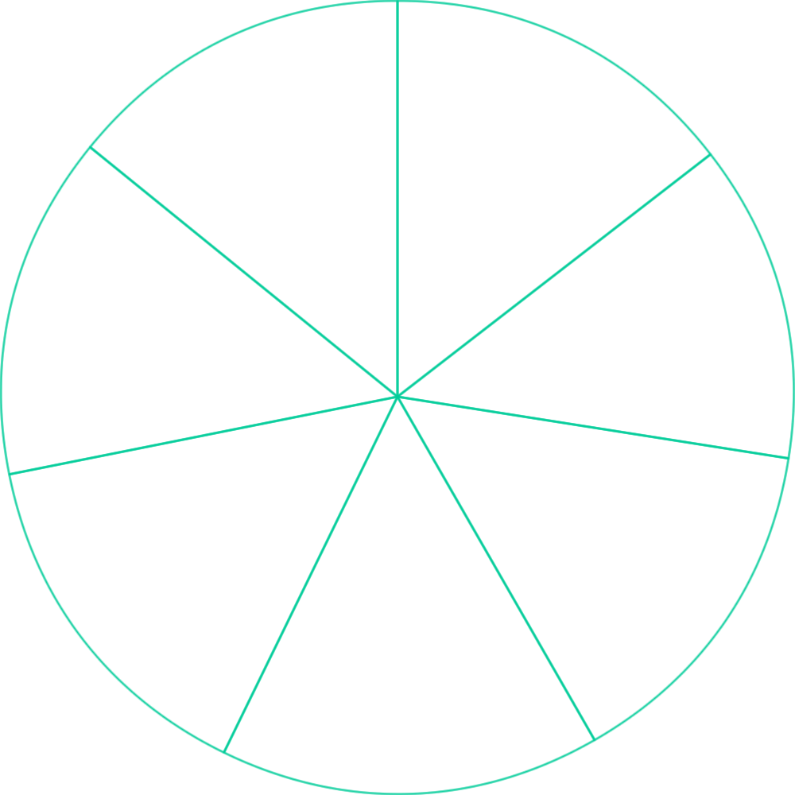

Cut and stick the pictures on to the life cycle wheel.

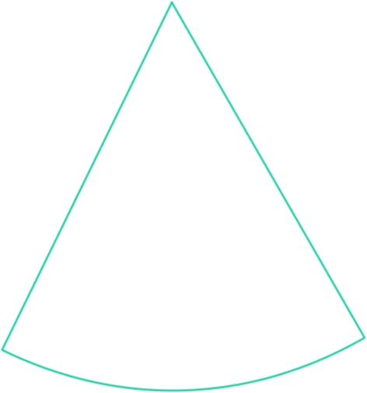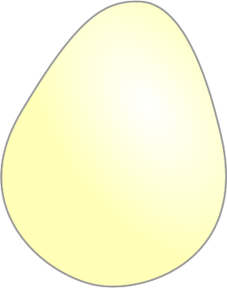
laying an egg
nest building

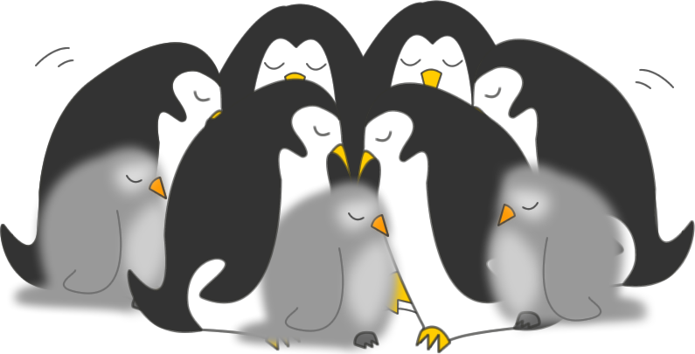
keeping warm
sitting on egg

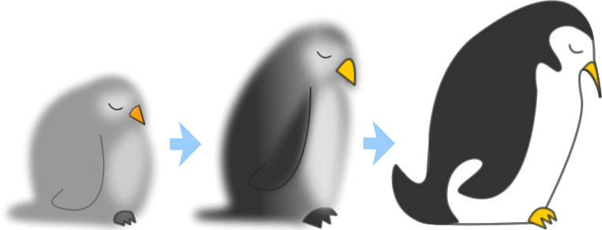
getting older
finding a mate


hatching

